*Classification:*

Major – Biochemistry

Minor – Biophysics and Computational Biology

*Title:* 135 character max including spaces

**Structure and Function of the HIV-1 5′ Polyadenylation Signal**

*Short Title:* < 50 characters

The 5′ polyA region is vital for RNA structure and function

**Joshua D Brown1, Saif Yasin1, Issac Chaudry, (Starting alphabetical order) Ghazal Becker, Grace Ghinger, Emma Neubert, Heer Patel, Sreeyasha Thapa, Al'yssa Williams,and Michael F. Summers1,\***

1Howard Hughes Medical Institute and Department of Chemistry and Biochemistry, University of Maryland Baltimore County, 1000 Hilltop Circle, Baltimore, MD 21250. *Corresponding authors: [summers@hhmi.umbc.edu](mailto:summers@hhmi.umbc.edu) (MFS)

*Keywords:*

HIV-1, 5′-leader, polyadenylation signal, RNA structure and function

*Footnotes:*

Author contributions: J.D.B., S.Y., I.C., and M.F.S. designed research; J.D.B., S.Y., I.C., xxx, yyy, and zzz performed research; all authors analyzed data; J.D.B., S.Y., I.C. and M.F.S. wrote the paper; all authors contributed to the editing of the manuscript.

**Abstract** 250 words max

The HIV-1 RNA genome contains a polyadenylation signal (AAUAAA) at both its 5′ and 3′ untranslated regions (UTR). While the 3′ polyadenylation signal is known to be involved in cleavage and the addition of the polyadenylation tail, the 5′ signal function is less characterized. We investigated the polyA region of both the monomeric and dimeric 5′-leader (5′-L) conformations and found that the region containing the 5′ polyadenylation signal is vital for 5′-L structure and function. In the dimeric conformation, the polyadenylation signal is within a hairpin stem-loop (polyA hairpin), which contains bulges that are highly conserved across multiple HIV strains and are all necessary for a global structural remodeling to the monomeric conformation by transcription start site modulation. Our studies give insight into the previously uncharacterized 5′ polyA region of HIV-1 and demonstrates evidence of its impact on structure, function, and fate of the viral RNA genome.

**Body**

The HIV-1 unspliced RNA genome is responsible for a diverse range of functions essential to the viral replication cycle, including genomic RNA (gRNA) packaging, mRNA splicing, and translation (1, 2). These activities are controlled by elements in the most conserved region of the viral RNA genome, the 5′ leader (5′-L), which acts as a dimeric structural-switch that modulates its structural elements and functions including TAR (transcription activation), polyadenylation signal, AUG (*gag* translation), PBS (transfer RNA primer binding), DIS (dimer initiation), ψ (packaging), SD (splicing), and U5 (dimer-monomer stability) (2-5). A conserved stretch of three guanines within the U3-R junction of the HIV-1 5′-long terminal repeat (5′-LTR) promoter results in the production of distinct RNA genomes beginning with the 5′-5′ triphosphate linked 7-methylguanosine residue followed by either one, two, or three guanosines (Cap1G, Cap2G, Cap3G, respectively) (6-8). All three RNA species (as well as their uncapped analogs Cap1G = 2G, Cap2G = 3G, Cap3G = 4G) exhibit specific dimerization behaviors, functions, and fates. The Cap1G start site favors a dimeric conformation, sequesters the cap residue, and is the predominant species packaged into new virus particles(6, 8). The addition of one or two canonical 5′ guanosines to make Cap2G or Cap3G, respectively, results in an equilibrium shift to the monomeric conformation, exposes the cap residue, and directs the RNA to be enriched within the polysomes (6, 8). This highlights the presence of different RNA populations with functions determined by the transcription start site (6-8). In addition, the monomer-dimer equilibrium is thermodynamically sensitive and remodeled at an energetic cost equivalent to a single G-C base pair (~3-5 kcal/mol) (6, 8).

Although the HIV-1 RNA contains equivalent untranslated regions (UTR) at both 5′ and 3′ terminals of the viral transcript, the functions are distinct(9). Notably, the polyadenylation region at the 3′ UTR is recognized by cleavage and polyadenylation specificity factor (CPSF) and cleavage stimulation factor (CStF), facilitating cleavage and the addition of a series of 3′ adenosine nucleotides (polyA tail) downstream from the polyadenylation hexamer sequence (AAUAAA)(10-12). The attachment of the 3′ polyA tail is an essential step for mRNA maturation which prevents degradation and plays a role in translation and splicing (11). It has been proposed that the upstream enhancer element (USE), unique to the 3′ UTR, serves as an initial binding site for the CPSF which subsequently binds to the polyadenylation hexamer sequence (10-12). Little is known of the function and importance of the 5′ polyA region other than its role as a template for reverse transcription (3, 7). Activation of polyadenylation in the 5′-UTR would result in early cleavage and a truncated, conceivably, non-functional transcript. However, despite the identical polyA sequence, the 5′ polyA signal remains inactive and does not promote cleavage or addition of a polyA tail, likely due to absence of the USE in the 5′ UTR (13, 14). Previous work proposed that a hairpin conformation of the 5′ polyA region, in addition to intrinsic structural properties of the rest of the 5′-UTR, inhibits polyadenylation factors from binding to this region of the RNA (15-17). Furthermore, other regulatory roles have been proposed for the 5′-polyA region, including the modulation of packaging, replication, and translation (16, 18).

High resolution nuclear magnetic resonance (NMR) spectroscopy studies have resolved the structure of the polyadenylation sequence in both the monomeric and dimeric 5′-leader (5′-L) conformations (8, 19). In the dimeric conformation, the polyadenylation signal is within the apical-loop of a semi-stable hairpin (polyA hairpin) that forms an end-to-end hairpin stacking conformation with the upstream adjacent TAR helix, sequestering the 5′-cap residue (8). In the monomeric conformation, the majority of the upstream half of the polyA hairpin sequence, including the polyadenylation hexamer sequence, is flexible and unstructured while the downstream sequence sequesters the dimer-promoting palindrome (8). Similar to other 5′-L structural elements, it is conceivable that 5′-polyA function is regulated by the dimerization state of the viral RNA (2).

Here, we used biochemical experiments and two-dimensional NMR techniques to study the structure and function of the polyA region. Using mutant constructs locked into monomeric and dimeric conformations as controls, gel electrophoresis migration assays allowed resolution of specific 5′-L conformations (Fig 1). Phylogenetic analyses have shown that the polyA hairpin contains bulges that are highly conserved in the major HIV-1 subtypes, and this work highlights that they are all necessary for a global structural remodeling to the monomeric conformation by transcription start site modulation. Our studies characterize the structure and function of the HIV-1 5′ polyA region and clarify its role in establishing a thermodynamic tipping point within the 5′-L that regulates viral RNA genome fate.

**Results**

*MLock and M*Lock Mutant Constructs*

The HIV-1 5′-leader (5′-L) exists in an equilibrium between a DIS-sequestered monomer (M), DIS-exposed monomer (M*), and dimer conformer (D) (Fig 1A). To create controls for these conformations, mutant 5′-L constructs were designed to lock the 5′-L into the M and M* conformation (MLock and M*Lock, respectively) (Fig S1 xxx). The MLock had a region of native A-A mismatches (A96:A287, A97:A286, A100:A283; [AAGCG:AGCAA]) mutated to canonical base pairs [UUACU:AGUAA]. This mutation also created a sequence that affords a unique upfield-shifted A-C2-1H signal (long-range probing by adenosine interaction detection [lr-AID]) (~6.5 parts per million) (Fig 1C). To create the M*Lock mutant construct, the DIS palindrome loop, was mutated to a GAGA tetraloop (Fig 1D). This simultaneously prevented the U5:DIS sequestering conformation and inhibited intermolecular dimerization. Despite MLock and M*Lock being nearly identical molecular weights, their distinct conformations allowed their migration to be resolved by gel electrophoresis (Fig 1B). In addition, they remained monomeric independent of concentration. NMR studies were conducted to ensure the locked constructs match wildtype-like conformations. NOE spectroscopy (NOESY) data of the MLock revealed the expected lr-AID signal at ~6.5 ppm confirming the formation of the U5-polyA:DIS interaction (Fig. 1C). Additionally, other native hairpin structures including TAR, ψ, PBS were able to be confirmed (Fig S1 xxx). NOESY data of the M*Lock was similar to the native intact 5′-L (Fig 1D). However, the M*Lock NOESY data was more resolved due to the halved size of the construct.

*The role of the polyA hairpin in the monomer-dimer equilibrium*

The HIV-1 5′-L monomer-dimer equilibrium involves a significant remodeling of the RNA structure with the polyA region undergoing a full conformational change. Its semi-stable hairpin in the dimer completely unwinds into an upstream unstructured region and downstream interaction to sequester the DIS hairpin loop and stem. The monomer-dimer equilibrium has already been proven to be sensitive to a single base pair at the bottom of the polyA hairpin stem where disruption of the C57-G103 base pair can shift the equilibrium to heavily favor the monomeric conformation (Fig 2B) (8). The polyA hairpin contains multiple mismatch bulges which destabilize the hairpin stem and it is conceivable that the semi-stability of the polyA hairpin is crucial to allow the large remodeling of the 5′-L in the monomer-dimer equilibrium. In order to investigate the full polyA hairpin’s effect on the monomer-dimer equilibrium, additional mutant constructs were designed, directed at the bulges (Fig 2A). Similar to previous results, the addition of one or two guanosines at the 5′ terminus of the 5′ UTR leads to the disruption of the base of the polyA hairpin by the G1 to C57 base pair. Mutagenesis of the C57 to a guanosine in a Cap1G leader destabilizes the base of the polyA hairpin and shifts the Cap1G leader to the monomer conformation, mimicking the effect of an additional 5′ guanosine (Fig 2B). A G103C rescue mutation restabilizes the base of the polyA hairpin and shifts the equilibrium back to the dimer (Fig 2B). We next investigated the role of the wildtype bulges on the monomer-dimer equilibrium through removing all bulges from the polyA hairpin (NB = ∆90, ∆92, C95U). The 3G-5′-L NB mutant construct shifted its equilibrium to favoring the dimeric conformation (Fig 2C), likely due to the increased stability of the polyA hairpin (NB polyA hairpin ∆G = -27.1 kcal/mol vs. WT polyA hairpin ∆G = -16.0 kcal/mol). We next investigated each individual bulge of the polyA hairpin. Surprisingly, removal of each bulge individually (∆90, ∆92, C95U) also resulted in complete shift to the dimer indicating that each bulge in the polyA hairpin is vital to maintain the native monomer-dimer equilibrium (Fig 2C). Rather than delete the bulged residues, we added in a residue to form a base pair with the bulged nucleotide (+G68, +A69). The +G68 mutant was consistent with the above results by stabilizing the dimer. However, the +A69 still maintained a monomeric population, albeit not as much as the WT 5′-L. This result is possibly due to the residues at the top of the polyA hairpin not forming part of the U5:DIS interface in the monomer (8). Thus, they are less vital to remodeling in the monomer-dimer equilibrium. We also investigated the effect of these mutations on the monomeric conformation (Fig 2E). The C95 is known to form a base pair with G288 in the monomeric conformation. The C95U mutation would instead form a U95:G288 wobble base pair but to ensure disruption of the monomeric conformation was not the reason for our results, we added a compensatory G288A mutation (Fig 2D). This C95U/G288A mutant still produced similar results where the dimeric conformation was heavily favored compared to the wild type (Fig 2C). The effect of the G288A mutation on the dimeric conformation is shown in Fig S2***. The U90 deletion resulted in loss of a residue predicted to be an unstructured/bulge region in the monomeric conformation (Fig 2D, gray residues). Despite the large size of the dimeric 5′-L constructs, the native A72-H2 produces an upfield signal that is isolated and able to be distinguished on a 1D spectrum. Using this native signal, 1D 1H NMR spectra of these 5′-L polyA mutant constructs was able to confirm formation of the polyA hairpin in each construct (Fig 2E).

The above results indicate that each native bulge of the polyA hairpin is crucial for the monomer-dimer equilibrium. To further investigate the top of the polyA stem, we added an additional GC base pair at the top adjacent to the polyA hairpin loop (Fig 2A; +CG). Despite this +CG mutant being as thermodynamically stable as the previous polyA hairpin mutants (+CG polyA hairpin ∆G = -19.5 kcal/mol vs. NB, ∆90, ∆92, C95U ∆G = <-19.4 kcal/mol), the +CG mutant maintained its monomeric conformation (Fig 2F). This finding suggests that the monomer-dimer equilibrium’s sensitivity to a single base pairs is highly dependent on the location of the base pair (bottom vs. top of the polyA hairpin stem). It is conceivable that the 5′-L monomer-dimer equilibrium is less sensitive to the stability of the top of the polyA hairpin due to this region not actively participating in new structural interactions in the monomeric conformation. This further supports the HIV-1 5′-L monomeric model proposed in Brown *et al.* 2020 where the upstream half of the polyA hairpin is unstructured.

*polyA hairpin structure*

To further characterize the structure of the polyA hairpin and the effect of these mutations, smaller polyA hairpin oligos were studied using NMR. Due to the significant size reduction in these oligos compared to the full 5′-L, signal broadening was minimal and advanced two-dimensional NMR experiments were able to be utilized. A portion of the assigned 2D 1H-1H NOESY spectrum for the wildtype polyA hairpin is shown in Fig 3A. The NOESY data for the wildtype polyA hairpin was compared to the polyA NB mutant (Fig 3B; WT = black, NB = red). The shift of A96 is expected due to the surrounding mutations. Due to the improved spectral quality, we were able to calculate the three-dimensional structure of the WT and NB polyA hairpins (Fig 3C, D).

*pH dependence of the HIV-1 5′-leader equilibrium*

The formation of an A-C wobble pair is not possible without protonation of the adenosine-N1 with the cytosine-O2 serving as the acceptor atom which occurs in acidic conditions (20). The above results showed that the monomer-dimer equilibrium is sensitive to a single base pair in the proper region of the stem. It is possible that the equilibrium is also sensitive to pH, mediated by the A65-C95 bulge in the polyA stem which would form a A-C wobble mismatch at a lower pH and stabilize the hairpin stem. In addition, it was found that HIV infected CD4+ T-lymphoblastoid cells have a significant decrease of intracellular pH from ~7.2 to ~6.7 over the course of approximately 4 days(21). To investigate the role of pH on the 5′-L conformation, we incubated the wildtype Cap3G-5′-L at pHs varying from 5.71 to 7.68. We found that a decrease in pH shifts the equilibrium to the dimeric conformation (Fig 5A). We designed a mutant which removed the A-C mismatch (3G-L371-A65C) and found that this mutant construct was resistant to pH changes and persistent as a monomer (Fig 5B). Appearance of a small amount of dimer for the 3G-L371-A65C at pH 5.71 suggests there may be another pH sensitive region in the 5′-L but the A65-C95 mismatch has the greatest effect. Another explanation is that C-C mismatches are also able to form at even more acidic conditions. In addition, we observed this small dimer population at a lower pH that was not measured in the literature (21). 2D 1H-1H NOESY spectrum of a wildtype polyA hairpin oligo at physiological pH 7.4 and acidic pH 6.6 were compared and showed resolution of the A65.H2 signal at the lower pH indicating a more stable base pair formation (Fig 5C). The three-dimensional structure of the wildtype polyA hairpin under these pH conditions are shown in Fig 5 E. This supports the hypothesis that the acidic pH results in formation of a wobble mismatch base pair between A65-C95 which stabilizes the polyA hairpin and resists remodeling to the monomeric conformation.

*Phylogenetic Analysis*

To further corroborate the necessity of the polyA semi-stability to the transcription start site mechanism, we performed phylogenetic and structural analysis of the polyA hairpin sequences of the main HIV-1 Group M subtypes. Representative strains for the major subtypes were identified by filtering through sequence data on the LANL HIV-1 Compendium (22) (see Methods and Supplementary Material). The LocARNA webserver was used to perform a structure-informed multiple sequence alignment of the polyA hairpin sequence from the representative strains(23-25). The sequence and predicted structures were largely conserved between all the major subtypes, including the G-C pair at the base of the hairpin that affords the transcription start site dependent mechanism and two bulged regions at positions 35 and 40 of the helix (Figure XA). The dimerization profile for the wildtype 2G (2G = Cap1G), 3G (3G = Cap2G), and 4G (4G = Cap3G) leaders for each of the subtypes was determined via agarose gel electrophoresis. The start site dependent modulation of the monomer-dimer equilibrium is conserved among most of the major subtypes (denoted by *) where 2G leaders are predominantly dimer and 3G and 4G leaders are predominantly monomer (Figure XB).

Additionally, we found stability of the polyA hairpin to be necessary across all subtypes for modulation of the monomer-dimer equilibrium by transcription start site. Focusing on a conserved bulged uridine residue, we removed the bulge in two separate mutations: inserting a complementary adenosine (UBI = uridine bulge insert) and removing the bulge residue (UBD = uridine bulge deleted). The UBI and UBD mutants for all subtypes, except F2, significantly perturbed the equilibrium to the dimer (Figure XB). By making analogous mutations to the C57G (Dsp = destabilized polyA) and C57G/G103C (Rsp = re-stabilized polyA) (Figure 2B) in each of the subtypes, we provide evidence that the mechanism by which transcription start site modulates the shift between monomer and dimer is conserved. Namely, the additional guanosine in a Cap2G or Cap3G leader pairs with the cytosine at the base of the polyA, leading to a full remodel. The Dsp and Rsp mutations corroborate this mechanism across all major subtypes. By mutating the cytosine at the 5′ base of the hairpin to a guanosine (Dsp) in a 2G leader, we see a shift to the monomer, and the rescue Rsp mutation that re-stabilizes the base of the polyA perturbs the equilibrium back to the dimer. (Figure XC). Together, these data suggest a conserved mechanism by which the 5′ polyA hairpin is a structural mediator for the switch between monomer and dimer by transcription start site. While the evidence suggests the stability of polyA and its role in the monomer dimer equilibrium is conserved, we were not able to find clear evidence for pH dependence for the monomer-dimer equilibrium in the representative strains (Figure XD – will likely be moved to supplementary material).

**Discussion**

Extensive studies on multiple regions of the HIV 5′-L have resulted in the RNA genome being implicated in functions such as transcription activation, translation, tRNA primer binding, dimer initiation, packaging, splicing, and monomer-dimer equilibrium control. Our previous work mapped the structures of the monomeric and dimeric equilibrium, revealing a monomeric structure with an upstream unstructured polyA region and extended polyA:DIS interaction, and a dimeric branched multihelical structure (8, 19, 26, 27). To facilitate the present study of the polyA region, we designed mutant 5′-L constructs that are locked into the monomeric and dimeric conformations (MLock and M*Lock). We were able to resolve their migration on gel electrophoresis mobility assays and confirm proper folding of these conformations by NMR studies which matched the native structures These constructs served as appropriate controls for our analysis of the polyA region’s effect on the monomer-dimer equilibrium.

Even considering the substantial work towards understanding the 5′-L, specific functions of the polyadenylation regions at the 5′ UTR have yet to be fully investigated. Computational folding predictions have suggested that the 3′ UTR polyadenylation region structure is variable between hairpin and linear conformations allowing subsequent cleavage and addition of the polyA tail(9). Other work has found that complete destabilization of the 5′ polyA hairpin resulted in premature polyadenylation and 3′ polyA hairpin stabilization resulted in complete loss of 3′ polyadenylation(15). This suggested that the regional structure of the polyadenylation signal is crucial in balancing 5′ polyadenylation repression while allowing 3′ polyadenylation.

Prior work has found that the monomer-dimer equilibrium is sensitive to the disruption of a single base pair at the bottom of the polyA hairpin(6, 8). The present studies found that increasing the stability of the hairpin by removal of all or a single bulge residue in the polyA hairpin stem results in prevention of dimer-to-monomer conversion. We found that the single base pair sensitivity involves the majority of the polyA hairpin stem, and that the semi-stability of the hairpin stem caused by the bulges are essential for proper monomer-dimer equilibrium balance. This suggests that unwinding of the lower portion polyA hairpin is necessary for transition to the monomeric structure which agrees with our proposed NMR-supported monomer model(8). It has been believed that the monomeric conformation is involved in translation and Boeras et al. found that disruption of the bottom of the polyA hairpin stem increased translation activity(5). It is conceivable that the unwinding of the polyA hairpin and resulting single stranded region serves as a loading site for translation machinery. In addition, previous studies showed that disruption of the polyA hairpin structure inhibited genome packaging and viral replication, but compensatory mutations restored packaging to near-wild-type levels(16, 28). Mutations that further stabilized the polyA hairpin beyond the wildtype still resulted in normal levels of genomic RNA(16). Based on our results, this is expected because a stabilized polyA hairpin would favor the dimer and subsequent packaging. In addition, prolonged culturing of mutant strains with disrupted polyA hairpins resulted in revertant viruses with rescue mutations that did not represent the wildtype sequence but restored the wildtype thermodynamic stability of the hairpin(16). All of the above suggest that it is not the sequence but rather the structure, specifically the thermodynamical stability, of the polyA region that is essential for viral function. Previous studies found that mutations to the polyA hairpin inhibit genome packaging and viral replication, but deletion of the entire hairpin did not affect dimerization or its NC binding properties(27). This further highlights the importance of the polyA hairpin specifically serving as a mediator in the monomer-dimer equilibrium.

Another significant function of the polyA hairpin, proposed in previous work involves trafficking of the viral RNA (reference P. Ding paper). When the cap residue is exposed on mRNA, it is captured by the cellular translation machinery and trafficked to the polysomes. HIV-1 gRNA avoids this by sequestration of its cap residue through end-to-end stacking interaction between the adjacent TAR and polyA hairpins preventing interaction with translation factors (8)(reference P. Ding paper). While mutations that open up the polyA hairpin result in decrease packaging, Das et al. found that deletion of only the upper part of the polyA hairpin, which allows a shorter hairpin to still form, produces normal levels of the genomic RNA(16). This is in agreement with our hypothesis as the hairpin formation could be sufficient to still allow the end-to-end hairpin stack, the necessary sequestration of the cap residue, and subsequent packaging.

The present study also found that acidic conditions push the monomer-dimer equilibrium towards the dimer for the Subtype A MAL strain. NMR and mutagenesis studies show that this is mediated by a single protonated A-C mismatch in the middle of the polyA hairpin stem. A-C wobble pairs are part of the less frequently observed mismatches in biology, but they are structurally different from Watson-Crick base pairs(29). They can create local helical structure irregularities and create electrostatic deviations in the grooves which can allow unique intermolecular recognition and interaction with other macromolecules(29). Protonation of A-C mismatches and formation of the A-C wobble base pairs has been implicated in numerous cellular functions(30-32). Notably, Bink et al. found that protonation of the a highly conserved A-C base pair is required for packaging and novel RNA-protein interactions of the turnip yellow mosaic virus (TYMV)(30). The effect of pH on HIV biology is an area that has not widely been investigated. Makutonina et al. found that there is a significant decrease of intracellular pH in infected CD4+ T-lymphoblastoid cells after approximately 4 days. We have already shown that HIV-1 has adapted to using a transcriptional start site heterogeneity to diversify its RNA pool(6-8). It is not beyond reason that HIV-1 uses this shift in pH to temporally control the fate of its RNA population. Early in the infected cell lifespan, at physiological pH, viral RNA constructs could more favor the monomeric conformation which promotes translation and stowing of viral protein machinery. Then, as the pH decreases when the cell has been fully prepared for the virus production phase, the equilibrium shifts to the dimer creating a larger population of genomic RNA species with opened NC-binding sites for subsequent packaging. Investigation of the impact of pH of viral RNA function is part of future work for our lab.

Our characterization of the polyA hairpin and its role in mediating the monomer-dimer equilibrium was also found to be largely conserved among most major subtypes in HIV-1 Group M. Sequence analysis and structure-informed multiple sequence alignment suggested the semi-stability of the 5′ polyA hairpin is evolutionarily conserved. This is in agreement with previous work done by Das et al. which showed that in a cellular system, viruses with a stable mutant 5′ polyA hairpins would accumulate mutations that reverted the hairpin to wildtype stability (16). Additionally, we probed the mechanism by which the polyA hairpin mediates the transition between monomer and dimer by mutagenesis and native gel electrophoresis to show what the mechanism is conserved between all major subtypes. Namely, an additional 5′ guanosine base pairs with a conserved cytosine residue at the base of the polyA to cause refolding of the 5′ leader. While the structural stability and role of the polyA in the monomer-dimer transition were found to be conserved, we did not find evidence of a conserved pH dependent A-C mismatch like we found in the MAL strain. To investigate beyond the representative strains, we looked at subtype wide sequence conservation at each position as sequence logos (Supplementary Material). Using an automated Python (insert GitHub link here) script to analyze the sequences in each of the subtype, we found that some strains from subtypes 02_AG (X%), A1(X%), and F1(X%) were predicted to have an A-C mismatch in the stem of the polyA hairpin. There is previous work implicating the structural integrity of the 5′ polyA in successful viral infection (5, 16, 33) while the exact mechanism to explain this phenomenon remained elusive. In the present study, we aimed to provide a potential structural basis for the role of the polyA in successful viral infection, specifically as a mediator for switching the genomic viral RNA between the monomer and dimer conformation by way of transcription start site heterogeneity.

In summary, our findings reveal how the HIV-1 5′-L monomer-dimer equilibrium is influenced by the 5′ polyadenylation region through hairpin structure stability. These conclusions are consistent with models from other proposals, including our previous work. Identifying specific involvement of the polyA hairpin with other functions such as capping, translation, and splicing could expand the role and importance of the region.

**Materials and Methods**

**DNA Template preparation and RNA *in vitro* Transcription**

The pUC19 vectors containing the different RNA clones were PCR amplified (EconoTaq PLUS 2X Master Mix, Lucigen) using a forward primer 20-30 nucleotides upstream to the T7 promoter site and a reverse primer with the first two nucleotides containing 2′ O-methyl modifications. RNAs were synthesized by *in vitro* transcription using 15 mL reactions, each containing 80 mM Tris·HCl (pH 9.0), 2 mM DTT, 20% (vol/vol) DMSO, 2 mM spermidine, 20 mM MgCl2, 3–6 mM NTPs (4x conc. of GMP was added to the reaction to prepare 5′MP RNA), ∼0.5 mg of PCR-amplified DNA template, and 0.15 mg T7 RNA polymerase. The reaction was quenched after a 6-h incubation at 37 °C by addition of 250 mM EDTA. RNA samples were heated for 5 minutes (100 °C) and snap cooled (0 °C, 5 minutes) prior to addition of 50% glycerol-water (volume/volume) and purification by electrophoresis on urea-containing polyacrylamide denaturing gels (SequaGel, National Diagnostics; 20 W for 12-18 hr). The gel bands were visualized by UV-shadowing, excised, and eluted using the Elutrap electroelution system (Whatman) at 150 V overnight (>16 hrs). The eluted RNAs were concentrated and washed with 2 M NaCl and then desalted using a 3 to 30-kDa MWCO Amicon Ultra-4 Centrifugal Filter Device (Millipore). The concentration of each sample was determined by measuring the optical absorbance at 260 nm.

**Native Agarose Gel Electrophoresis**

The RNA was incubated at 1-10 µM at 37 °C overnight (>16 hrs) in the designated buffer; PI (physiological ions; 10 mM K­H2PO4, pH 7.4 (varied in pH dependent gel electrophoresis study), 1 mM MgCl2, 122 mM KCl) or low ionic strength conditions (10 mM NaCl, 10 mM Tris, pH 7.4). Samples were immediately placed on ice when removed from the incubator. Native agarose gel loading solution containing 0.17% Bromophenol Blue and 40% (vol/vol) sucrose was added to each sample and mixed. 250-1000 ng of each sample was loaded onto a 1% (vol/vol) agarose TBM gel containing 0.2 mM MgCl2 in the gel and running buffer and ethidium bromide at a final concentration of 0.5 µg/mL. Gels were resolved at room temperature at 115 V for 75 min and visualized by UV illumination.

**NMR spectroscopy**

Samples for NMR studies of the control oligos (550 μL of ~100 μM RNA in D2O [99.8%; CIL] in a 5 mm Bruker NMR sample tube) were prepared in 10 mM KH2PO4 buffer (pD = 7.4). Samples for NMR studies of the dimeric RNA (Cap1G) and its control oligos (340 μL of ~100-150 μM RNA in D2O [99.8%; CIL] in a 5 mm Bruker Shaped sample tube) were prepared in PI (physiological ions; 10 mM K­H2PO4, pD 7.4, 1 mM MgCl2, 122 mM KCl). Samples were also prepared in 90% H2O + 10% D2O to observe the exchangeable H8 of the cap residue. NMR data of the large RNAs (>120 nts) were collected with a Bruker AVANCE spectrometer (800 MHz, 1H, 37 °C), Non-exchangeable 1H assignments were obtained from 2D NOESY data (NOE mixing time = 650 ms, relaxation delay = 3.0 - 4.4 s, T = 35 °C). NMR data of the smaller control oligos (<120 nts) were collected with a Bruker AVANCE spectrometer (600 MHz, 1H, 35 °C). Non-exchangeable 1H assignments were obtained from 2D NOESY data (NOE mixing time = 300 ms, relaxation delay = 2.0 s, T = 35 °C). All NMR data were processed with NMRFx (34) and analyzed with NMRViewJ (35).

**NMR spectral analysis**

Initially, assignments were made for fully protonated RNA fragments based on 2D 1H-1H NOESY, 1H-1H TOCSY, and 1H-13C HMQC spectra (36). Assignments of these control RNAs were expedited using RNAShifts2’s chemical shift prediction software (37). Assignments from control RNAs were transposed from the control dataset to a 5′-L dataset. 2D NOESY spectra were recorded for the 5′-L RNA with a variety of labeling schemes. Prefixes denote sites of protonation, all other sites deuterated; e.g., GH = fully protonated guanosines, A2r = adenosines protonated at C2 and ribose carbons. Intraresidue NOEs were generally assigned from AH-, CH-, GH-, and UH-labeled samples. Cross-strand H2-H1′, H2-H2, and sequential H2(i)-H1′ (i+1) NOEs were assigned from AH-, A2rGr-, A2rCr-, and A2rUr-labeled samples. Sequential H8(i)-ribose(i-1), sequential H6(i)-ribose(i-1), sequential aromatic [H8/6(i)-H8/6(i+1), H2(i)-H8/6(i+1), and H2(i)-H2(i+1)], sequential H6/8(i)-H5(i+1) and H5(i)-H5(i+1), and sequential H1′-H1′ NOEs were assigned from AH-, CH-, GH-, UH-, AHGH-, AHCH-, AHUH-, CHGH-, GHUH-, CHUH-labeled samples.

**Secondary Structure Predictions**

Secondary structures were predicted with MFOLD (38) or RNAStructure (39).

**Structure calculations\*\*\***

Initial ensembles of structures were generated with CYANA. NOE-derived distance restraints were binned using standard categorization (upper 1H-1H distance limits of 2.7, 3.2, and 5.0 Å for NOE cross peaks of strong, medium, and weak intensity, respectively) except as follows, to allow greater conformational sampling: Medium-intensity intraresidue H8/6 to H2′ and H3′ NOEs = 4.0 and 3.0 Å, respectively; weak adenosine-H2 noes = 7.0 Å (for highly deuterated samples). Torsion angle restraints were employed for regions of A-helical geometry, allowing for ± 25° deviations from ideality (α=−62°, β=180°, γ=48°, δ=83°, ɛ=−152°, ζ=−73°). Hydrogen bonding restraints were used, and cross-helix P–P distance restraints (with 20% weighting coefficient) were employed for A-form helical segments to prevent collapse of major grooves (40).

The 20 CYANA-minimized structures with lowest target function were subjected to energy minimization in AMBER (41). The upper limit NOE and H-bond distance restraints were employed, along with restraints to enforce planarity of aromatic residues and standard atomic covalent geometries (40). No backbone torsion angle or inter-phosphate restraints were employed during AMBER refinement. Minimizations were performed using RNA.OL3 (42) and generalized Born (43) force fields with parameters appropriate for RNA (igb=8, saltcon=0.15, rgbmax=25, cut=25). The force field was modified to accommodate the Cap residue by using pre-defined parameters for 7-methylguanosine (from tRNA, based on (44)) and guanosine diphosphate (based on (45)). Structures were analyzed with PyMOL (46).

**Identification of Representative Strains from Major Groups in HIV-1**

The 5′ polyA sequence was identified and aligned using the SequenceLocator and AnalyzeAlign tools on the LANL website (https://www.hiv.lanl.gov/content/sequence/HIV/mainpage.html) (47). The results of the AnalyzeAlign tool were sorted based off major subtype. For each subtype, a strain with a representative polyA for that subtype was chosen for our *in vitro* analysis.

**Acknowledgements**

**Figure Captions**

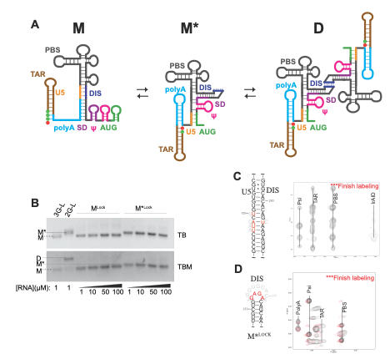

**Figure 1. HIV-1 RNA Monomer-Dimer Equilibrium**

**(A)** Cartoon representation of the HIV-1 5′-L monomer-dimer equilibrium. The monomeric conformation (M) contains an unstructured polyA region whereas the dimer-promoting conformation (M*) contains a polyA hairpin and exposed DIS palindrome which facilitates dimerization (D). **(B)** MLock adopts a conformation that migrates similarly to the 3G-L371 on both TB & TBM gels. The M*Lock migration rate matches the 2G-L371 on TB gel but remains monomeric on TBM even at higher concentrations. **(C)** Secondary structure of MLock depicting mutations (red residues) made to the extended U5:DIS region to stabilize the monomeric conformation. An lrAID (long-range probing by adenosine interaction detection) was simultaneously incorporated to enable direct detection of cross-strand 1H-1H nuclear Overhauser effects (NOEs). **(D)** Secondary structure of M*Lock, where DIS residues A273-A281 were mutated to GAGA (red residues) to prevent dimerization and U5 interaction. Region of the 2D 1H–1H NOESY spectrum of M*Lock shows polyA hairpin, U5:AUG helix, and exposed DIS stem formation.

** Figure 2. polyA hairpin is vital for TSS modulation**

**(A**) Secondary structure of the polyA hairpin with mutation sites denoted by red labels. **(B)** Disruption of a single base pair (C57-G103) by C57 to G mutagenesis shifts Cap1G-L371 from the M* to M conformer on TB and disrupts dimerization on TBM. **(C)** Removal of all the bulges (NB = ∆U90, ∆C92, and C95U) or removal of a single bulge (U90, ∆C92, C95U, +G68, or +A69) results in 3G-L371 dimer stabilization due to loss of sensitivity to the start site 5′-guanosine number. Rescue mutation to re-stabilization the monomeric conformation (C95U/G288A, fig. Sx) still favors the dimeric conformation. Free energy values of the polyA hairpin residues with the corresponding mutations are labeled below the gel. (D) Cartoon secondary structure representing location of polyA mutations in the NMR-derived monomeric conformation(8). **(F)** Overlapped 1D spectra of the various polyA mutant leaders shows confirmation of the TAR, polyA, PBS, and Psi hairpin formations. **(E)** Addition of an extra CG base pair at the top of the polyA stem in (A) does not affect the monomer-dimer equilibrium.

**Figure 3. (A)** Region of the 2D 1H–1H NOESY spectrum of the polyA hairpin. **(B)** 2D 1H–1H NOESY spectra of the polyA hairpin WT and polyA-NB hairpin mutant. Removal of the bulges results in new upfield shifted A.H2 signals. **(C)** Three-dimensional structure of the polyA hairpin compared to the polyA-NB mutant hairpin

**Figure 4. Influence of pH on RNA structure and function**

**(A)** Acidic pH shifts the HIV-1 5′-L monomer-dimer equilibrium to the dimeric conformation. Removal of the A65-C95 mismatch by A65 to C mutagenesis results in loss of the 5′-L pH sensitivity. Appearance of a small amount of dimer at pH 5.71 suggests there may be another pH sensitive region in the 5′-L but the A65-C95 mismatch has the greatest effect. **(B)** Lowering the pH from 7.4 (black) to 5.5 (red) results in sharpening of the A65.H2 signal in the polyA hairpin due to A65-C95 base pair formation. **(C)** Three-dimensional structure of the polyA hairpin at varying pH values.

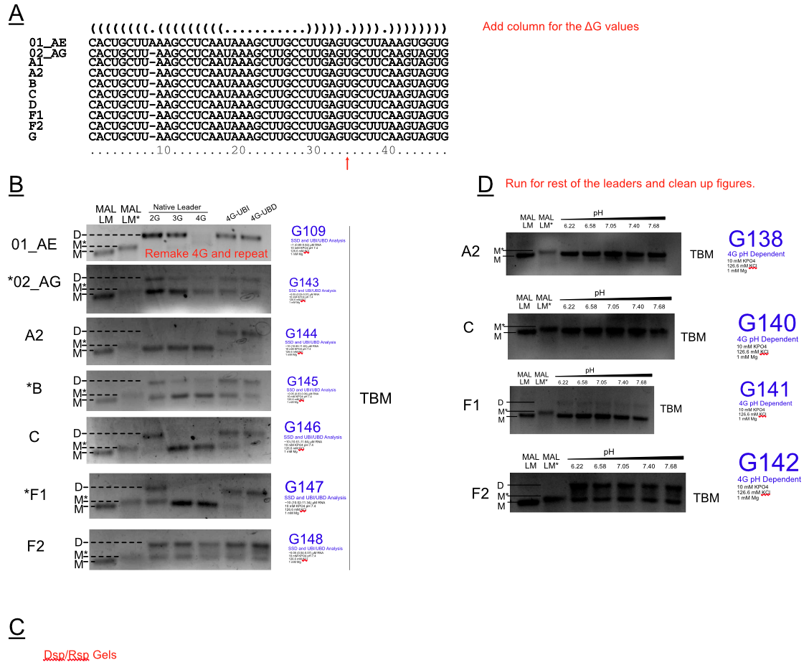

**Figure X. TSSH and polyA Stability are Conserved Among Major HIV Subtypes**

**(A**) Structure-informed sequence alignment of the 5′ polyA hairpin of representative strains of the major subtypes using LocARNA-P(23-25) suggests strong conservation of polyA sequence. The consensus structure is denoted by the Vienna String format above the alignment . Additionally, the *in silico* predicted free energy of each of the hairpins is ***kJ/mol ± *** **(B)** Electrophoretic analysis of the 5′-L of major HIV-1 subtypes demonstrates *in vitro* conservation of 5′ start site shifting the monomer-dimer equilibrium for most of the subtypes tested (denoted by *). Stabilizing an uracil conserved bulge (red arrow, panel A) in a 4G-L by a deletion (UBD = Uracil Bulge Deletion) or inserting a stabilizing cross-strand adenosine (UBI = Uracil Bulge Insertion) perturbs the equilibrium to the dimer. **(C)** Mutations analogous to the C57G and C57G/G103C were made in each of the subtypes. All subtypes exhibit a shift to monomer upon destabilization by C57G. The dimer population is recused by the additional G103C mutation.**(D)** Testing the pH sensitivity of the monomer-dimer equilibrium of other suggests this phenomenon is not conserved among major HIV-1 subtypes.

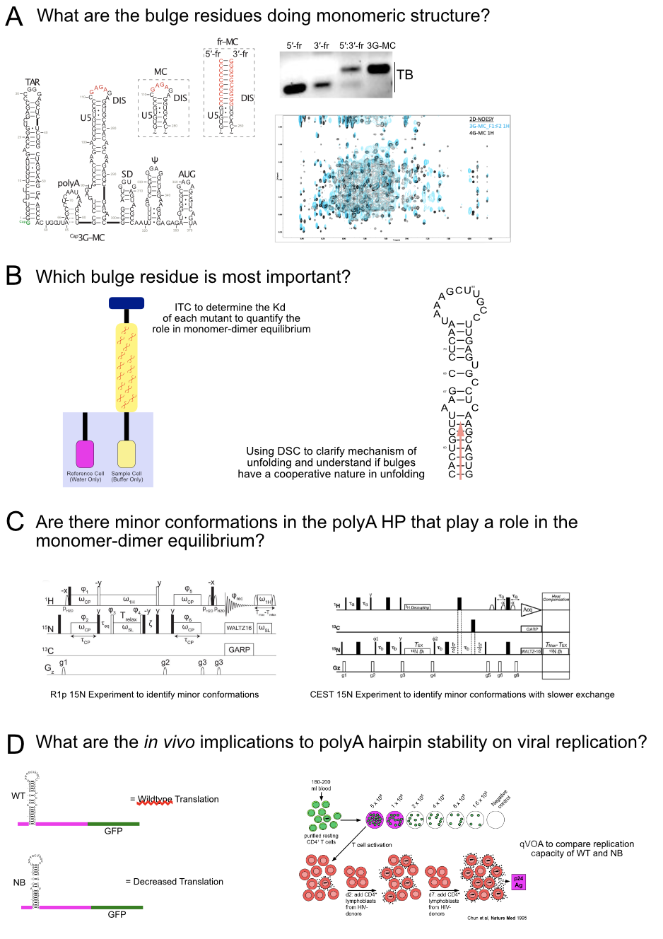

**Figure Y. Future Studies that could be done**

Major questions that still remain include clarifying the structure of the monomer, the specific mechanistic roles of the bulges, and the *in vivo* implications of these results. (A) 3-dimensional Structure determination can be completed of Monomer Core to evaluate the nature of PolyA in the monomer through utilizing the fragment annealing approach. (B) Evaluation of the importance of each bulge can be further delineated through discriminating between the Kd of each mutant through ITC and through DSC studies to monitor unfolding upon thermal denaturation. (C) Use of R1p and CEST experiments can help us clarify the role the bulges have on allowing minor conformations that may regulate the monomer-dimer equilibrium. (D) Studies of translation and use of a quantitative viral outgrowth assay can give initial information on the role the stability of the polyA has on viral replication. Further work can be proposed to identify the specific step that replication is interrupted.

**References**

1. S. C. Keane, M. F. Summers, NMR Studies of the Structure and Function of the HIV-1 5'-Leader. *Viruses* **8** (2016).

2. K. Lu *et al.*, NMR detection of structures in the HIV-1 5´-leader RNA that regulate genome packaging. *Science* **344**, 242-245 (2011).

3. J. M. Coffin, S. H. Hughes, H. E. Varmus, *Retroviruses* (Cold Spring Harbor Laboratory Press, Plainview, N.Y., 1997).

4. A. M. Lever, HIV-1 RNA packaging. *Adv Pharmacol* **55**, 1-32 (2007).

5. I. Boeras *et al.*, The basal translation rate of authentic HIV-1 RNA is regulated by 5'UTR nt-pairings at junction of R and U5. *Sci Rep* **7**, 6902 (2017).

6. S. Kharytonchyk *et al.*, Transcriptional start site heterogeneity modulates the structure and function of the HIV-1 genome. *Proc Natl Acad Sci U S A* **113**, 13378-13383 (2016).

7. T. Masuda *et al.*, Fate of HIV-1 cDNA intermediates during reverse transcription is dictated by transcription initiation site of virus genomic RNA. *Sci Rep* **5**, 17680 (2015).

8. J. D. Brown, Kharytonchyk, S., Chaudry, I., Iyer, A. S., Carter, H., Becker, G., Desai, Y., Glang, L., Choi, S. H., Singh, K., Lopresti, M. W., Orellana, M., Rodriguez, T., Oboh, U., Hijji, J., Ghinger, F. G., Stewart, K., Frances, D., Edwards, B., Chen, P., Case, D. A., Telesnitsky, A., Summers, M. F., Structural basis for transcriptional start site control of HIV-1 RNA fate. *Science* **368**, 413-417 (2020).

9. A. H. Gee, W. Kasprzak, B. A. Shapiro, Structural differentiation of the HIV-1 polyA signals. *J Biomol Struct Dyn* **23**, 417-428 (2006).

10. W. Keller, L. Minvielle-Sebastia, A comparison of mammalian and yeast pre-mRNA 3'-end processing. *Curr Opin Cell Biol* **9**, 329-336 (1997).

11. D. F. Colgan, J. L. Manley, Mechanism and regulation of mRNA polyadenylation. *Genes Dev* **11**, 2755-2766 (1997).

12. C. C. MacDonald, J. Wilusz, T. Shenk, The 64-kilodalton subunit of the CstF polyadenylation factor binds to pre-mRNAs downstream of the cleavage site and influences cleavage site location. *Mol Cell Biol* **14**, 6647-6654 (1994).

13. A. Valsamakis, N. Schek, J. C. Alwine, Elements upstream of the AAUAAA within the human immunodeficiency virus polyadenylation signal are required for efficient polyadenylation in vitro. *Mol Cell Biol* **12**, 3699-3705 (1992).

14. A. Valsamakis, S. Zeichner, S. Carswell, J. C. Alwine, The human immunodeficiency virus type 1 polyadenylylation signal: a 3' long terminal repeat element upstream of the AAUAAA necessary for efficient polyadenylylation. *Proc Natl Acad Sci U S A* **88**, 2108-2112 (1991).

15. A. T. Das, B. Klaver, B. Berkhout, A hairpin structure in the R region of the human immunodeficiency virus type 1 RNA genome is instrumental in polyadenylation site selection. *J Virol* **73**, 81-91 (1999).

16. A. T. Das, B. Klaver, B. I. Klasens, J. L. van Wamel, B. Berkhout, A conserved hairpin motif in the R-U5 region of the human immunodeficiency virus type 1 RNA genome is essential for replication. *J Virol* **71**, 2346-2356 (1997).

17. B. I. Klasens, M. Thiesen, A. Virtanen, B. Berkhout, The ability of the HIV-1 AAUAAA signal to bind poly adenylation factors is controlled by local RNA structure. *Nucleic Acids Res.* **27**, 446-454 (1999).

18. A. M. Borman, Y. M. Michel, K. M. Kean, Biochemical characterisation of cap-poly(A) synergy in rabbit reticulocyte lysates: the eIF4G-PABP interaction increases the functional affinity of eIF4E for the capped mRNA 5'-end. *Nucleic Acids Res* **28**, 4068-4075 (2000).

19. S. C. Keane *et al.*, NMR detection of intermolecular interaction sites in the dimeric 5'-leader of the HIV-1 genome. *Proc Natl Acad Sci U S A* **113**, 13033-13038 (2016).

20. W. N. Hunter, T. Brown, O. Kennard, Structural features and hydration of a dodecamer duplex containing two C.A mispairs. *Nucleic Acids Res* **15**, 6589-6606 (1987).

21. A. Makutonina *et al.*, Human immunodeficiency virus infection of T-lymphoblastoid cells reduces intracellular pH. *Journal of virology* **70**, 7049-7055 (1996).

22. Anonymous (2016) Los Alamos HIV sequence compendium 2016.

23. S. Will, I. L. Joshi T Fau - Hofacker, P. F. Hofacker Il Fau - Stadler, R. Stadler Pf Fau - Backofen, R. Backofen, LocARNA-P: accurate boundary prediction and improved detection of structural RNAs.

24. S. Will, I. L. Reiche K Fau - Hofacker, P. F. Hofacker Il Fau - Stadler, R. Stadler Pf Fau - Backofen, R. Backofen, Inferring noncoding RNA families and classes by means of genome-scale structure-based clustering.

25. M. Raden *et al.*, Freiburg RNA tools: a central online resource for RNA-focused research and teaching. *Nucleic Acids Research* **46**, W25-W29 (2018).

26. S. C. Keane *et al.*, Structure of the HIV-1 RNA packaging signal. *Science* **348**, 917-921 (2015).

27. X. Heng *et al.*, Identification of a minimal region of the HIV-1 5'-leader required for RNA dimerization, NC binding, and packaging. *J Mol Biol* **417**, 224-239 (2012).

28. J. L. Clever, D. A. Eckstein, T. G. Parslow, Genetic dissociation of the encapsidation and reverse transcription functions in the 5' R region of human immunodeficiency virus type 1. *J. of Virology* **73**, 101-109 (1999).

29. A. Garg, U. Heinemann, A novel form of RNA double helix based on G.U and C.A(+) wobble base pairing. *RNA* **24**, 209-218 (2018).

30. H. H. Bink, K. Hellendoorn, J. van der Meulen, C. W. Pleij, Protonation of non-Watson-Crick base pairs and encapsidation of turnip yellow mosaic virus RNA. *Proc Natl Acad Sci U S A* **99**, 13465-13470 (2002).

31. A. Rich, D. R. Davies, F. H. Crick, J. D. Watson, The molecular structure of polyadenylic acid. *J Mol Biol* **3**, 71-86 (1961).

32. S. Chakraborty, S. Sharma, P. K. Maiti, Y. Krishnan, The poly dA helix: a new structural motif for high performance DNA-based molecular switches. *Nucleic Acids Res* **37**, 2810-2817 (2009).

33. J. L. Clever, D. A. Eckstein, T. G. Parslow, Genetic dissociation of the encapsidation and reverse transcription functions in the 5' R region of human immunodeficiency virus type 1. *J Virol* **73**, 101-109 (1999).

34. M. Norris, B. Fetler, J. Marchant, B. A. Johnson, NMRFx Processor: a cross-platform NMR data processing program. *Journal of biomolecular NMR* 10.1007/s10858-016-0049-6, 1-12 (2016).

35. B. A. Johnson, R. A. Blevins, NMRview: a Computer Program for the Visualization and Analysis of NMR Data. *J. Biomol. NMR* **4**, 603-614 (1994).

36. K. Wüthrich, *NMR of Proteins and Nucleic Acids* (John Wiley & Sons, New York, 1986).

37. J. D. Brown, M. F. Summers, B. A. Johnson, Prediction of hydrogen and carbon chemical shifts from RNA using database mining and support vector regression. *Journal of biomolecular NMR* **63**, 39-52 (2015).

38. M. Zuker, Mfold web server for nucleic acid folding and hybridization prediction. *Nucleic Acids Res* **31**, 3406-3415 (2003).

39. J. S. Reuter, D. H. Mathews, RNAstructure: software for RNA secondary structure prediction and analysis. *BMC bioinformatics* **11**, 129 (2010).

40. B. S. Tolbert *et al.*, Major groove width variations in RNA structures determined by NMR and impact of 13C residual chemical shift anisotropy and 1H-13C residual dipolar coupling on refinement. *J. Biomol. NMR* **47**, 205-219 (2010).

41. D. A. Case *et al.*, The Amber biomolecular simulation programs. *J. Computat. Chem.* **26**, 1668-1688 (2005).

42. M. Zgarbova *et al.*, Refinement of the Cornell et al. Nucleic Acids Force Field Based on Reference Quantum Chemical Calculations of Glycosidic Torsion Profiles. *J Chem Theory Comput* **7**, 2886-2902 (2011).

43. J. Mongan, C. Simmerling, J. A. McCammon, D. A. Case, A. Onufriev, Generalized born model with a simple, robust molecular volume correction. *J. Chem. Theory Comput.* **3**, 156-169 (2007).

44. R. Aduri *et al.*, AMBER Force Field Parameters for the Naturally Occurring Modified Nucleosides in RNA. *J Chem Theory Comput* **3**, 1464-1475 (2007).

45. K. L. Meagher, L. T. Redman, H. A. Carlson, Development of polyphosphate parameters for use with the AMBER force field. *J Comput Chem* **24**, 1016-1025 (2003).

46. W. L. DeLano (2002) The PyMOL molecular graphics system. (DeLano Scientific, San Carlos, CA).

47. <https://www.hiv.lanl.gov/> (